EXPERIMENT-10

Aim: Examples on how to create INDEXES, create VIEWS, VIEWS WITH CHECK OPTION INSERT, DELETE, DROP on VIEWS

INDEXES:
A SQL index is used to retrieve data from a database very fast. Indexing a table or view is, without a doubt, one of the best ways to improve the performance of queries and applications. Indexes are special lookup tables that the database search engine can use to speed up data retrieval.

Create an indexes:
Syntax:
create index index_name on table_name(col1,col2,col3,….);

Example:
Create index emp_name_93 on EMPLOYEE_93(Fname);

Output :
Example:
Create index dept_name_93 on DEPARTMENT_93(Dname);
Output :

Drop an index:
Syntax:
drop index index_name on table_name;
Example:
Drop index emp_name_93 on EMPLOYEE_93;
Output :

Example:
Drop index dept_name_93 on DEPARTMENT_93;
Output :

VIEWS:
VIEWS are virtual tables.VIEWS are allows users to do the following
Structure data in a way that users or classes of users find natural or intuitive. Restrict access to the data in such a way that a user can see and (sometimes) modify exactly what they need and no more. Summarize data from various tables which can be used to generate reports.

Creation:

Syntax:
create view view_name as select col1,col2,… from table_name where condition.
Example:
create view Manager_Names_93 as select Ssn,Fname,Minit,Lname from EMPLOYEE_93,DEPARTMENT_93 where Ssn=Mgr_Ssn;
select * from Manager_Names_93;
Output:
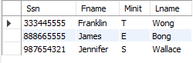
Example:
create view Names_93 as select Ssn,Fname,Minit,Lname from EMPLOYEE_93;
select * from Names_93;
Output:
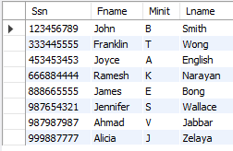

Example:
create view Dept_Info_93(Dname,No_of_Emp,Total_Salary) as select Dname,count(*),sum(Salary) from EMPLOYEE_93,DEPARTMENT_93 where Dno=Dnumber group by Dname;
select * from Dept_Info_93;

Output:
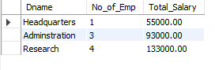
- INSERT:
Syntax:
insert into view_name(col1,col2,…) values(data1,data2,…);

Example:

insert into Names_93(Ssn,Fname,Minit,Lname) value('191827345','Alice','S','Wall');
select * from Names_93;
Output:
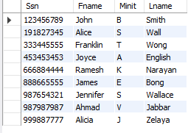

Example:

insert into Names_93(Ssn,Fname,Minit,Lname) value('Alice','S','Wall');

Output:

Example:

insert into Names_93(Ssn,Lname) values('12345678','Ram');

select * from Names_93;

Output:
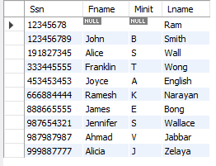
- DELETE:
Syntax:
delete from view_name where condition;

Example:
delete from Names_93 where Ssn=’191827345’;
select * from Names_93;

Output:
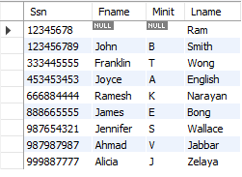

Example:
delete from Names_93 where Lname='Ram';
select * from Names_93;
Output:
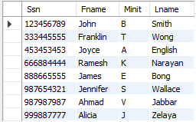
- SELECT :

Syntax:
select col1,col2 from view_name_93 where condition;

Example:
select Ssn,concat(Fname," ",Lname) AS Manager_Names
,Dependent_Name from Manager_Names_93,DEPENDENT_93 where Ssn=Essn;

Output:
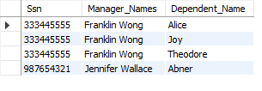

Example:
Select concat(Fname," ",Lname) as Name,minit from Manager_Names_93;

Output:

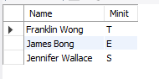
- DROP:

Syntax:
drop view view_name;

Example:

drop view Manager_Names_93;
Output:

Example:

drop view Names_93;

Output:

